**ENCAPSULATION:**

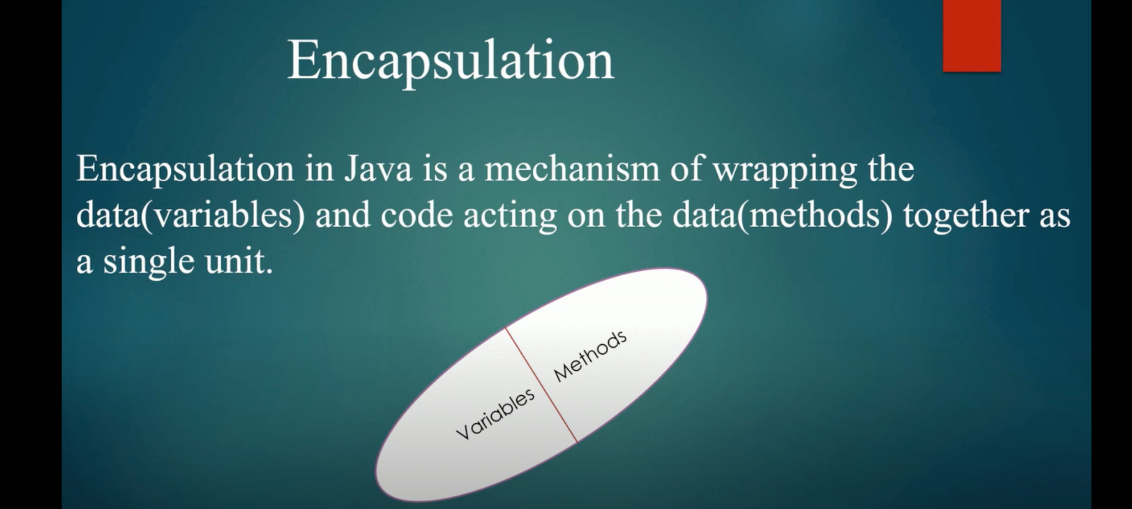

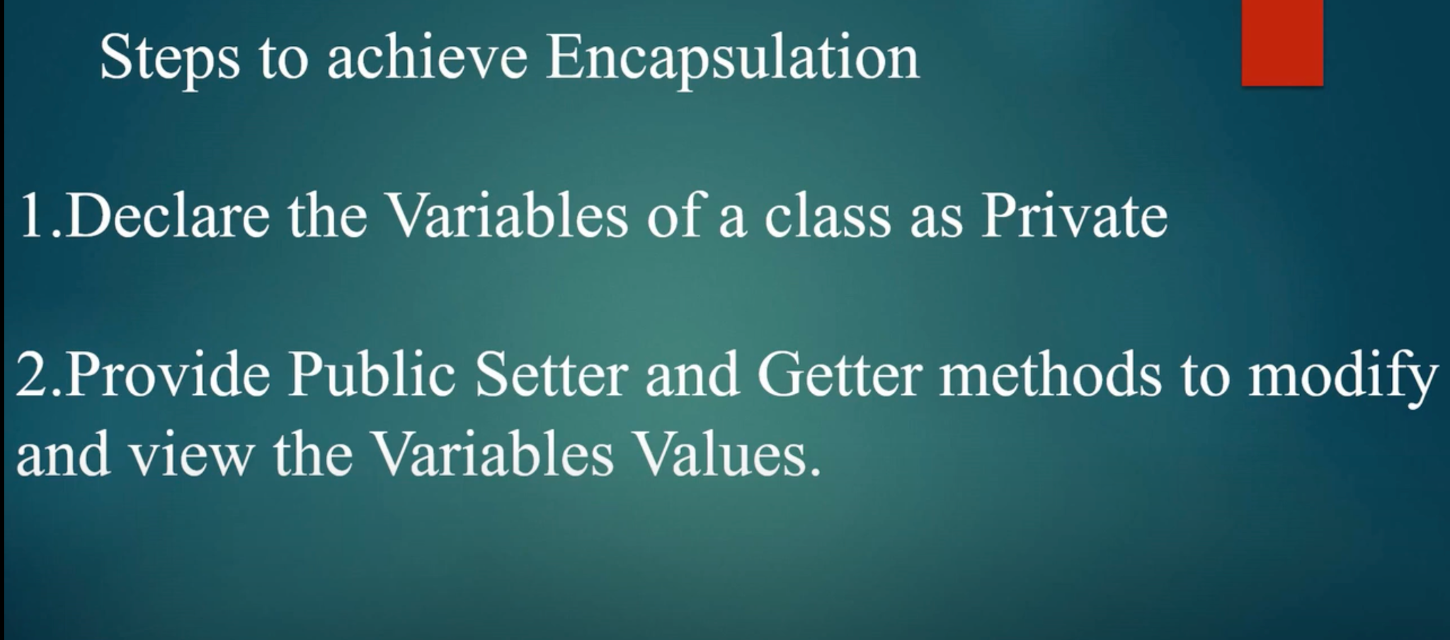

**Declaring the variables as private is called data-hiding which means that private variables in this method can be accessed only by the methods that are available in this class.**

